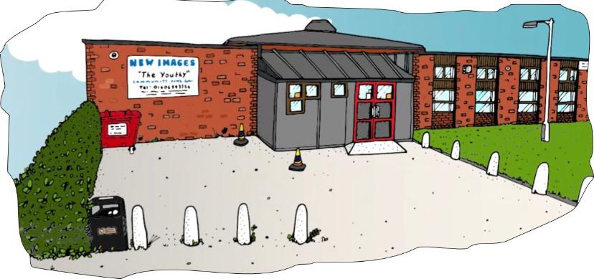
TRUSTEE APPLICATION FORM

Please complete the Trustee application form and send to: debbie.cragg@wycf.co.uk

Full Name
Title |  |  | Preferred Name
Home Address | Post Code
Telephone (please indicate preferred with a *) | Home |  |  | Mobile
 | Work
E-mail

We are looking for a range of people with different skills sets to complement our current board. Please tell us the following (continue a separate sheet):

- Can you tell us about your background and what attracted you to this role?

- What personal qualities do you think make a good Trustee – and which personal qualities do you feel you would bring to the role?

- What skills will you bring to enhance the growth and work of Winsford Youth & Community Forum?

